Ex.No.2 Study of Network cable
1. Understand different types of Network cable.
2. Make a cross-wired cable and straight through cable using clamping/crimping tool.
a) Understand different types of network cable.
Different type of cables used in networking are:
1. Unshielded Twisted Pair (UTP) Cable
2. Shielded Twisted Pair (STP) Cable
3. Coaxial Cable
4. Fibre Optic Cable
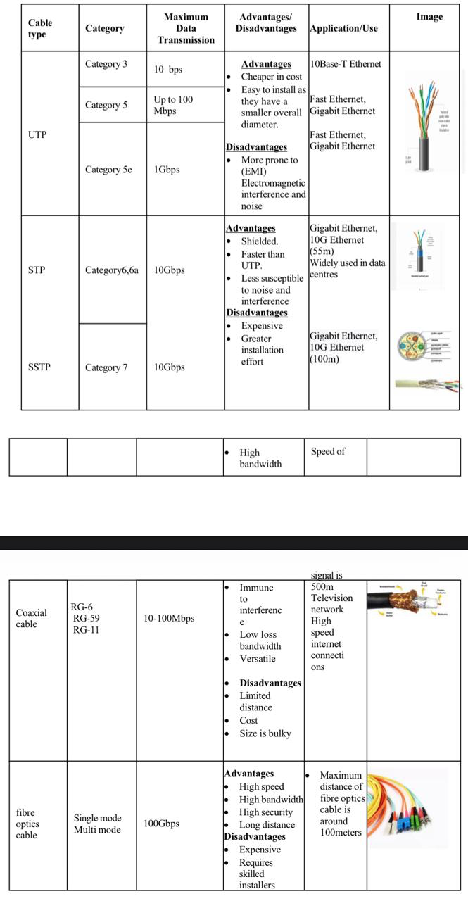
(b) Make Your Own Ethernet Cross-Over Cable/ Straight cable
Tools and parts needed:

1.Ethernet cabling. CAT5e is certified for gigabit support, but CAT5
cabling works as well, just over shorter distances.
2.A crimping tool. This is an all-in-one networking tool shaped to push
down the pins in the plug and strip and cut the shielding off the
cables.
3.Two RJ45 plugs.
4.Optional two plug shields.
5.Ethernet Cable (CAT5e/CAT5)
6.CAT5e is recommended because it supports Gigabit Ethernet (1000 Mbps).
7.CAT5 also works but supports lower speeds and shorter distances.
8.Crimping Tool
9.A networking tool used to:
o Strip the outer insulation of the cable.
o Arrange and trim the wires.
o Crimp (press) the RJ45 connector onto the cable.

10.RJ45 Connectors (2)
11.Plastic connectors fitted at both ends of the Ethernet cable.
12. Used to connect the cable to computers, switches, routers, etc.
13.Plug Shields (Optional)
14.Protective covers placed over the RJ45 connectors.
15.Prevent damage to the locking clip and reduce strain on the cable.

RESULT:
Thus study of network cables have been studied and executed.

